**REQUIREMENTS FAVORITE SETTINGS**

**As you apply different filters, sorting or groupings you can add them as favorites**

**Because each time you sign out, all those will be back to default**

**By adding to favorites with one click you can go back to it instead of filtering, sorting from beginning**

**You can add to public favorites which anybody assigned to the project can see**

**Or you can add to the private only you can see and use**

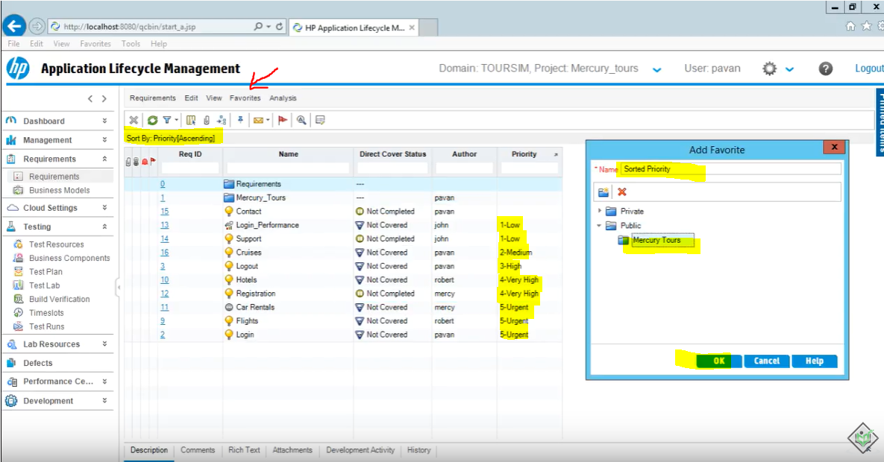

**Then you can click on favorites and select it,**

**You can go back to it with one click**

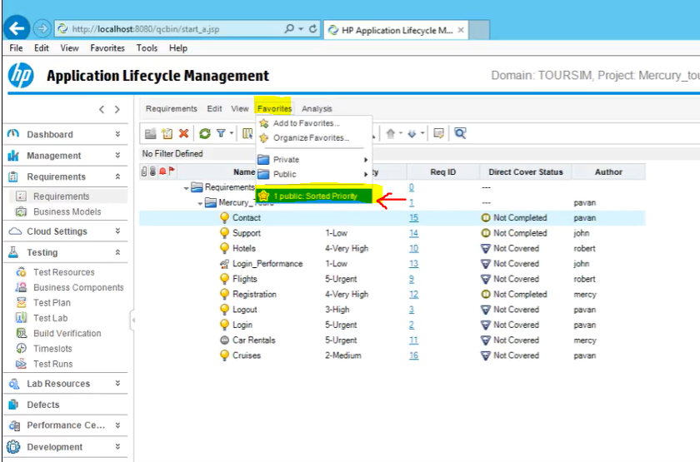

**Goes right back to it**

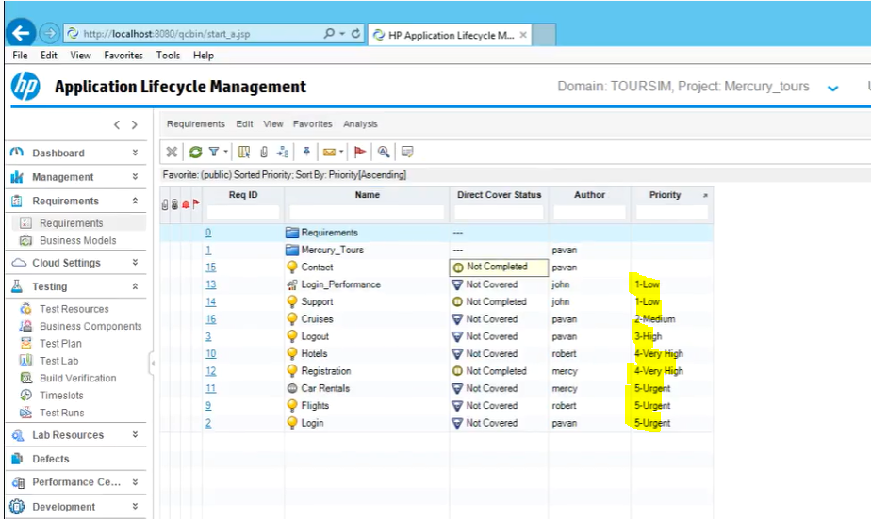

**You can also delete it from organize favorites**

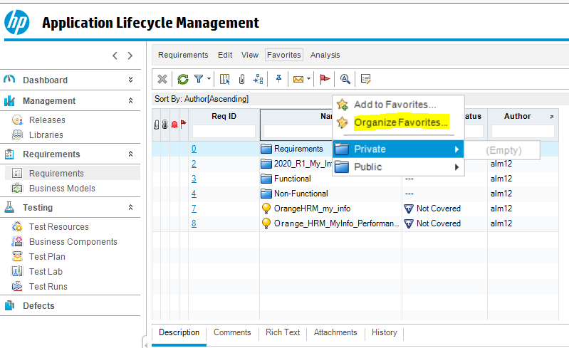

**and click on X**

